**TRIBHUVAN UNIVERSITY**

Faculty of Management

**National College of Computer Studies**

Paknajol,Kathmandu

**Python**

**Report on**

**Mushroom Classification**

**Submitted By:** **Submitted To:**

Name: Prerana Giri Mr. Mausam Rajbanshi

BIM 5rd Semester

Section: B

Roll no.:17

TU Reg. No.:7-2-551-220-2020

**Submission Date:________________**

**Acknowledgement**

We would like to express our gratitude to Mr. Mausam Rajbanshi for their guidance and support throughout the writing process. His insights and expertise were invaluable in helping us to understand the topic and produce a high-quality report.

We are also grateful to National College of Computer Studies who gave us the opportunity to do this wonderful project. This report would not have been possible without the support of so many people, and we are deeply grateful for their contributions.

Contents

**1.** **Introduction** 1

**1.1.** **Background** 1

**1.2.** **Objectives** 1

**2.** **Source code and Output** 2

• Import Libraries 2

• Read the data 2

• See Structure 3

• See information about dataset 4

• Get description 4

• Define target(y) and features (x) 5

• Co-relation between columns 5

• Sklearn labelencoder 6

• Train, test and split 6

• Predict the model 7

• Classification report 7

**3.** **Conclusion** 8

# **Introduction**

Fetal **mushroom**, the [conspicuous](https://www.merriam-webster.com/dictionary/conspicuous) umbrella-shaped fruiting body (sporophore) of certain [fungi](https://www.britannica.com/science/fungus), typically of the order [Agaricales](https://www.britannica.com/science/Agaricales) in the phylum [Basidiomycota](https://www.britannica.com/science/Basidiomycota) but also of some other groups. Popularly, the term mushroom is used to identify the edible sporophores; the term [toadstool](https://www.britannica.com/science/toadstool) is often reserved for inedible or poisonous sporophores. There is, however, no scientific distinction between the two names, and either can be properly applied to any fleshy fungus fruiting structure. A mushroom or toadstool is the fleshy, [spore](https://en.wikipedia.org/wiki/Spore)-bearing [fruiting body](https://en.wikipedia.org/wiki/Sporocarp_(fungi)) of a [fungus](https://en.wikipedia.org/wiki/Fungus), typically produced above ground, on soil, or on its [food](https://en.wikipedia.org/wiki/Food) source. Toadstool generally denotes one poisonous to humans.

## **Background**

The Mushroom classification is a beginner machine learning problem and the objective is to correctly classify if the mushroom is edible or poisonous by it's specifications like cap shape, cap color, gill color, etc. using different classifiers.

## **Objectives**

* The purpose of this report is to process a dataset using Python programming language.
* This dataset used in this project contains 8124 instances of mushrooms with 23 features like cap-shape, cap-surface, cap-color, bruises, odor, etc.

The python libraries and packages we’ll use in this project are namely:

NumPy

Pandas

Seaborn

Matplotlib

Scikit-learn

# **Source code and Output**

### Import Libraries

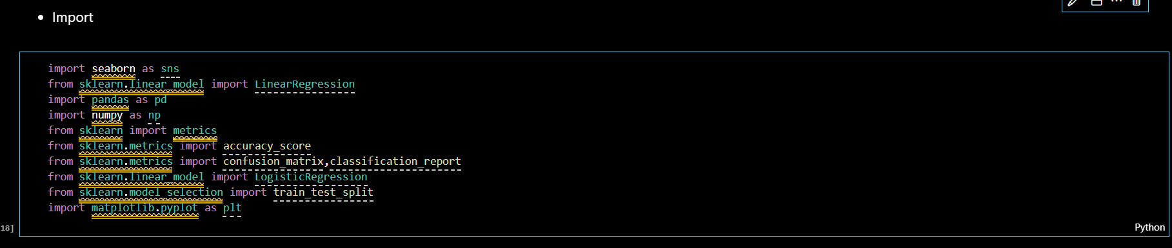

### Read the data

### See Structure

### See information about dataset

### Get description

### Define target(y) and features (x)

### Co-relation between columns

### Sklearn labelencoder

### Train, test and split

### Predict the model

### Classification report

# **Conclusion**

* In conclusion, With confusion matrix we saw that our train and test datas balanced, so there is no problem in there. Most of classfication methods hit 100% accuracy with this dataset.